For this project, I use exploratory testing method and Ad-hoc method both belong to Black box method.

The bugs in this website as followed:

- In popular Make Module, if you click “Votes” it will break the order and cannot be recovered.
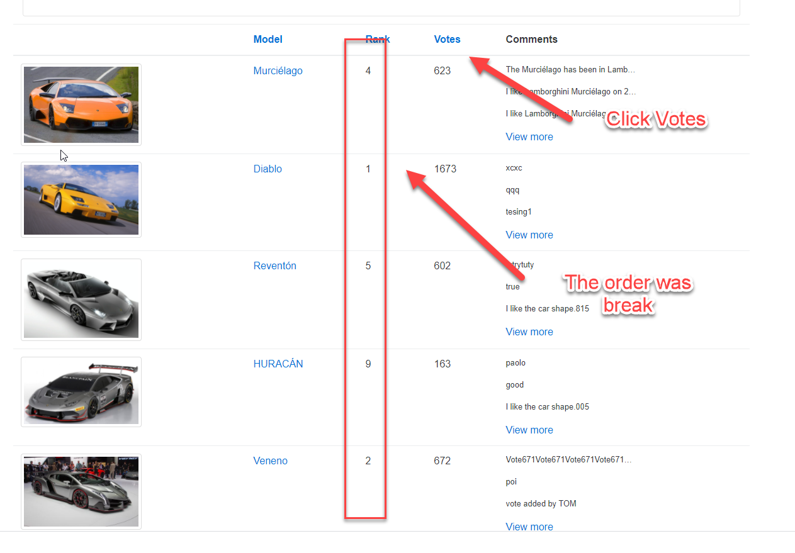

- “Model” does not work in popular make module, there is no response if the model hyperlink is clicked in popular make module.
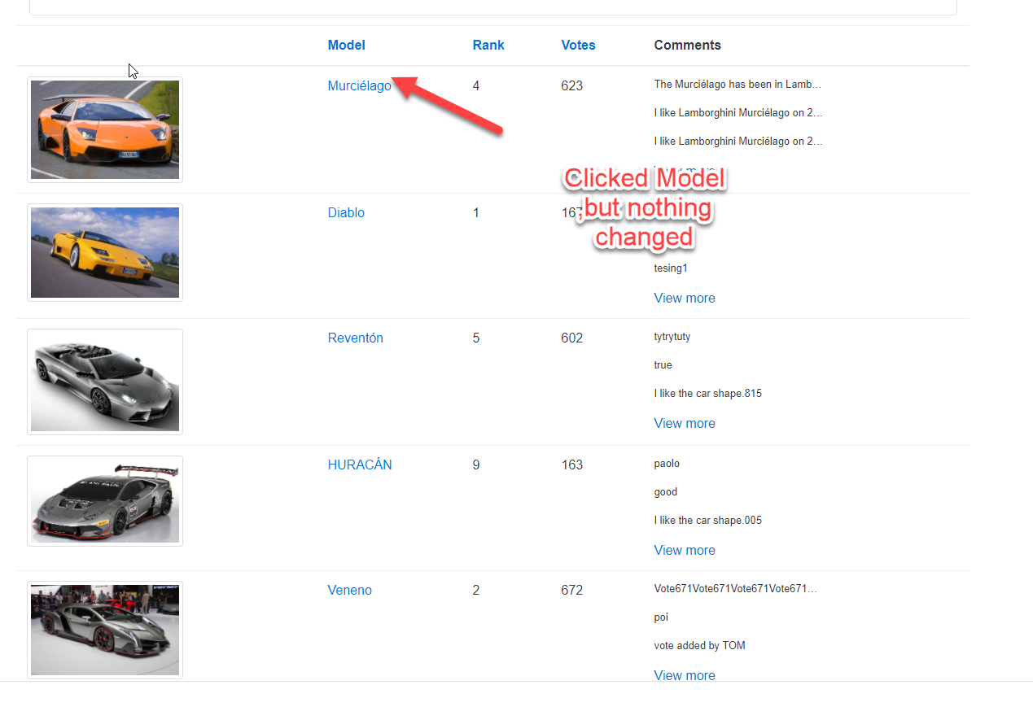

- “Rank ” does not work in popular make module, there is no response if the rank hyperlink is click after the order is break.
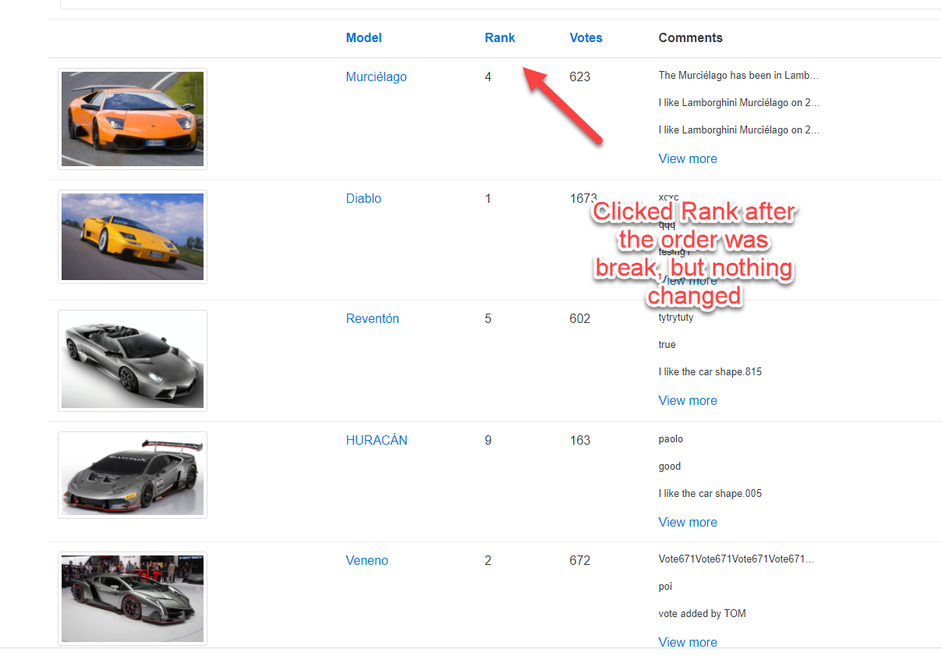
- “Buggy Rating” hyperlink does not work in popular module, it is supposed to get back home page if “Buggy Rating” is clicked.
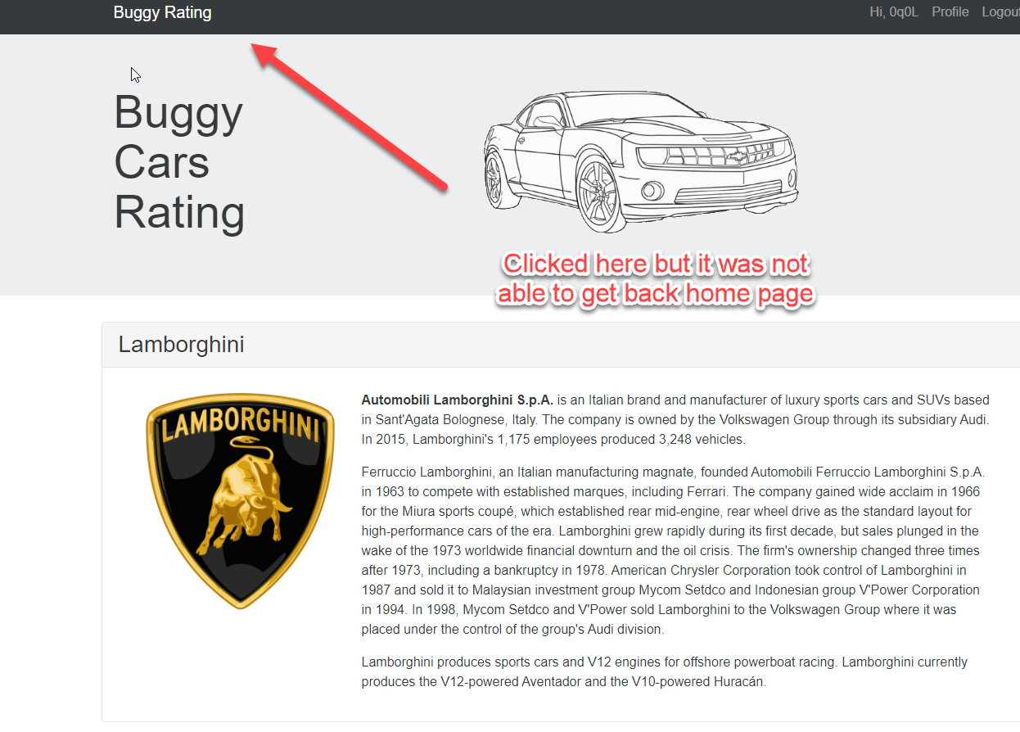
- Popular Model cannot be accessed in Fire Fox browser.
